Preparation of your Abstract for ISAR-7
Symposium

P. Bear^{1*}, A. Fox² and A. Char³

¹Consortium for Arctic Environmental Research, USA
²Arctic Environment Research Center, National Institute of Polar Research, Japan
³World Meteorological Organization, Switzerland
A one-page abstract should be prepared in the following format: (1) Use a sheet of A4 size paper. (2) Start the first line leaving the space of 2.5 cm on the upper side. (3) Title of the paper (Arial type 16 points, bold, first letters caps, centered) could span in maximum three rows, and is followed by one blank line. (4) Author’s names are written (Times type 12 points, centered) with the order of first name and family names, followed by one blank line. Authors are separated by commas and marked with superscript when necessary to distinguish authors from different affiliations. The presenting author’s name should be marked with *. (5) Author’s affiliations (times type 12 points, italic, centered) are written in separate rows. (6) Insert one blank line between the affiliations and the main text. (7) Use 12 points Times type for the main text and smaller fonts may be used for figure captions. (8) Leave the space of 2.5cm on the both side of the text. (9) Main text should be fully justified with five spacing. (10) Leave the space of 2.5 cm at least on the bottom of the text. Page number will be printed there. (11) References should be indicated in the text in square brackets, such as [1-3] and listed at the end of the paper (11 points). (12) Figures should be high quality graphics, line drawings, or black and white photographs, and placed preceding the reference list. (13) Acknowledgement may be addressed as a last paragraph of the text body. (14) Please upload this document by PDF. (15) Deadline is 31 October 2022. (16) Your abstract will be uploaded to ISAR-7s website, and the title and authors will be in the program published.

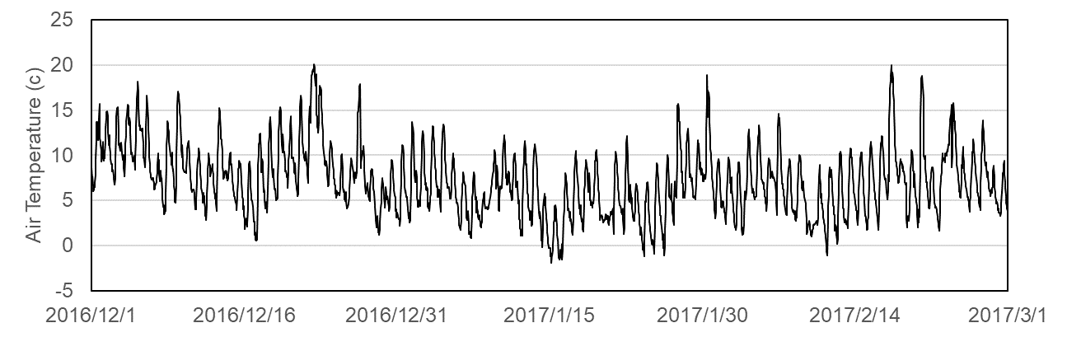

Figure 1. Air temperature in Tokyo

References
[1] C.R. Climate, I.C. Breaker Jr., Arctic sea ice change in winter, Polar Science 251 (2007)

